Fiction

Here is where you can find all of our chapter books! Books like Harry Potter, Diary of a Wimpy Kid, Hunger Games, and much, much more!

Each book has an AR (Accelerated Reader) score on the spine.

Top number : Book’s reading level

Bottom number : the points for the book’s quiz

AR

5.5

6 pts

Unscramble the words!

[**ansfyta**](https://www.wordunscrambler.net/?word=ansfyta) ____________

[**oarncme**](https://www.wordunscrambler.net/?word=oarncme) ____________

[**eeccnis**](https://www.wordunscrambler.net/?word=eeccnis) [**citifon**](https://www.wordunscrambler.net/?word=citifon) ____________

[**aedvnetur**](https://www.wordunscrambler.net/?word=aedvnetur) ____________

[**iorlshaitc**](https://www.wordunscrambler.net/?word=iorlshaitc) [**citifon**](https://www.wordunscrambler.net/?word=citifon) ____________

[**ysrmyte**](https://www.wordunscrambler.net/?word=ysrmyte) ____________

Word Bank:

Mystery Adventure Romance HistoricalFiction ScienceFiction Fantasy

Question: What is your favorite book? (Write this on your map)

Monthly Genre and National Month

Here is where I display books about different topics for the month.

One side is about genres, or different types of books

The other side is about the National Month, which is the subject that is celebrated for that whole month.

Genres

Action, Adventure, Comedy, Mystery, Fantasy, Historical fiction, Horror, Romance, Science fiction, Thriller, Western

National Months

National back to school month, Hispanic Heritage month, Black History Month, National Writing Month, Women’s History Month

Question: What is your favorite season? (Put this on your map)

Topic of the Week

Here you can find books and information about a unique topic every week!

Also you can put a topic into the suggestion box!

Trivia Questions

1. What is the name of the fat orange cat that loves lasagna?

_______________________________________________

1. What do you call a kitten that does somersaults in the air?

_______________________________________________

1. Write three facts about WildCat, the robot cat.

_______________________________________________

1. Name 5 cat characters in books.

_______________________________________________

1. Why do cats hate water?

_______________________________________________

Question : Tell me something you’d like to know more about! (Put this on your map)

Library Computers

The library has a few computers that you can use for research, AR tests, and looking up books.

Here are a few rules for using the computers.

1. The computers ______ for school or ____________ only
2. Please be ____________ of other ___________ using the computers
3. No games
4. Use only appropriate __________
5. No _______ or drink.
6. Please ask Mrs. ______ if you have any ___________!

Word Bank

questions Classwork websites food Endo respectful students are

Question: What pets do you have? (Put this on your map)

Non-Fiction

This section has all of the books based on fact! There are books in many categories including biography, business, cooking, health and fitness, pets, crafts, home decorating, languages, travel, home improvement, religion, art and music, history, self-help, true crime, science and humor.

These books are sorted by number which decided by what topic they are about. Match the numbers below to their topic.

000 Science

100 History and Geography

200 Technology

300 Arts and Recreation

400 Literature

500 Computer Science and Information

600 Religion

700 Social Studies

800 Language

900 Philosophy and Psychology

Question: What is your favorite subject? (Put this on your map)

Autobiography and Biography

7 19 22 8 22 / 26 9 22 / 25 12 12 16 8 / 4 9 18 7 7 22 13 / 26 25 12 6 7 /

21 26 14 12 6 8 / 11 22 12 11 15 22 / 12 9 / 18 13 21 15 6 22 13 7 18 26 15 /

11 22 12 11 15 22 / 7 19 9 12 6 20 19 12 6 7 / 19 18 8 7 12 9 2.

25 18 12 20 9 26 11 19 2 / 18 8 / 26 13 / 26 24 24 12 6 13 7 / 12 21 /

8 12 14 22 12 13 22 ' 8 / 15 18 21 22 / 4 9 18 7 7 22 13 / 25 2 /

8 12 14 22 12 13 22 / 22 15 8 22.

26 6 7 12 25 18 12 20 9 26 11 19 2 / 18 8 / 26 13 / 26 24 24 12 6 13 7 / 12 21 / 26

/ 11 22 9 8 12 13 ' 8 / 15 18 21 22 / 4 9 18 7 7 22 13 / 25 2 / 7 19 26 7 /

11 22 9 8 12 13.

A=26

Question : Who is your favorite singer or actor? (Put this on your map)

Sora

What is Sora?

Sora is a digital resource for books and audiobooks. All you need is your gmail login information and you can start checking out books! You can also access other libraries if you have a library card for them!

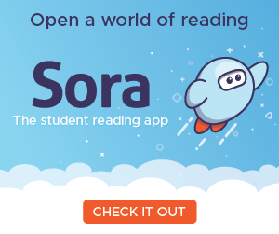Follow the directions on the pole or ask Mrs. Endo if you have any questions.

Question: Tell me a book you would like to read on Sora. (Put this on your map)

Checking Out and Rules

You can check out anything you want: Books, Graphic Novels, Non-fiction books, etc. When you want to check out, bring the book to the Librarian, Mrs. Endo.

You can check 3 books at a time

You can check out the book for 3 weeks

You can renew as many times as you need to

Every day the book is overdue, it is 10 cents a day to a max of $5.00

If you lose the book, you have the pay to replace it

Please be gentle with the books

Please return the books to Mrs. Endo or into the Library Book Drop

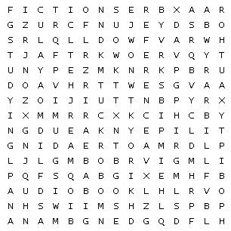

|  |  |  |
| --- | --- | --- |
| adventure | audiobook | author |
| biography | fiction | Graphic novel |
| librarian | library | overdue |
| reading | reference | studying |

Question: What is the librarian’s name? (Put this on your map)

Reference

Here you can find books about almost every topic and can learn lots about different things. This section is good to help with research or just to learn cool facts to tell your friends.

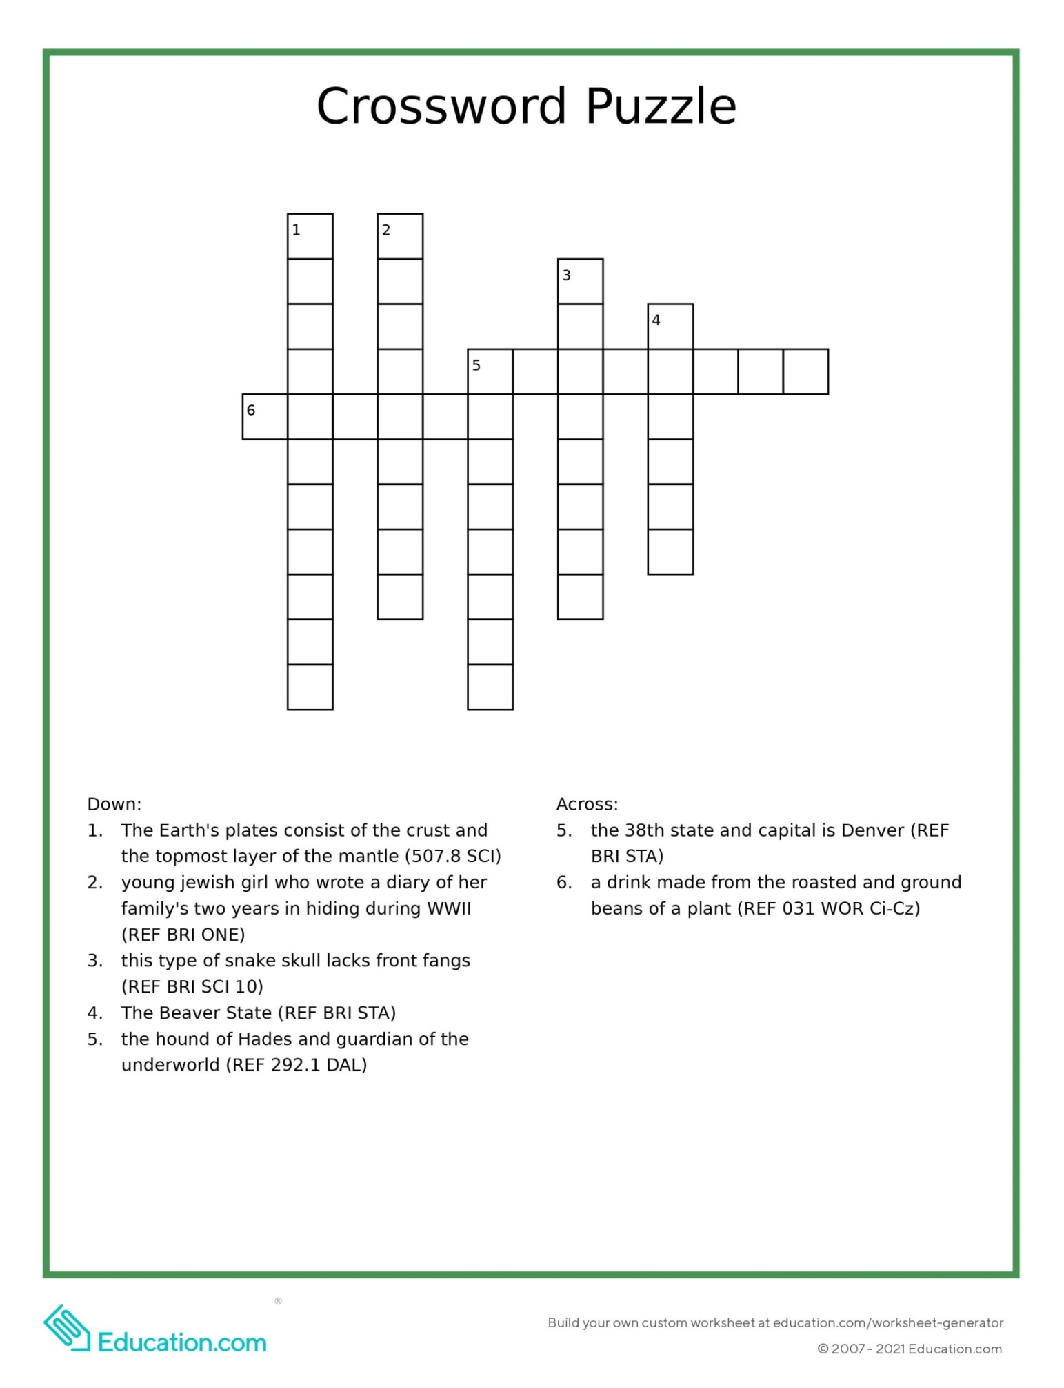

Question: Use the books to learn a fact about birds. (Put this on your map)

Graphic Novels

These are novels that use pictures and images as well as text to help tell a story.

Graphic novels can be new stories, but they can also be adaptations of novels or classic stories.

**Match the Call number to the title of the book**

GN B LEE The Silver Six

GN SCI ECO The Challenger Disaster

GN HIS NAU Lumberjanes

GN F EME The Boy Who Became a Dragon

GN HA Exploring Ecosystems with MaxAtom

GN KIM Brain Camp

GN F LIE Zebrafish

GN F STE Almost American Girl

Question : What is your favorite color? (Put this on your map)